**Why did Britain govern Palestine-Israel between 1920 and 1948?**

**Lesson 4**

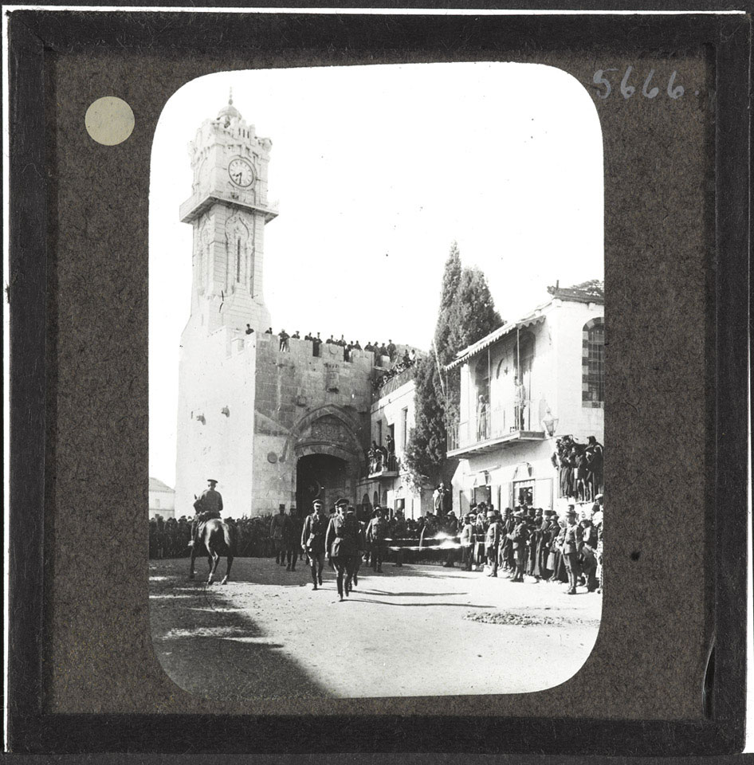

General Allenby enters Jerusalem in December 1917

**By the end of this lesson, you should be able to:**

Define Mandate Palestine

Explain why Britain governed Palestine-Israel between 1920 and 1948

Compare Britain’s promises to Palestinians and Jews at this time

**Keywords**

Mandate

British Empire

Self-determination

League of Nations

**Knowledge check!**

1)What is Zionism? What did nineteenth century and early twentieth century Zionists want?

2)What did Palestinian nationalists want at this time?

3)What three contradictory promises did Britain make to Jews and Palestinians during WWI?

**The Treaty of Versailles**

The First World War ended on 11th November 1918, when Germany surrendered and all nations agreed to stop fighting. On 28th June 1919, the **Treaty of Versailles** formally ended the war. This was negotiated at the **Paris Peace Conference** and was signed by Germany, Britain, France, Italy and Russia

The Treaty of Versailles had huge consequences for Germany. Germany had to accept full responsibility for the war under the ‘War Guilt Clause’ (Clause 231) and it lost a lot of territory. It lost 13% of its European territory, including Alsace-Lorraine, Eupen and Malmedy, Northern Schleswig, West Prussia and Silesia. Outside Europe, Germany lost all its colonies. Overall, Germany lost 10% of its population. Germany also had to pay 132 billion gold marks in reparations, which is the equivalent of $269 billion today. There were also military restrictions on the country: the Rhineland became a demilitarised zone (no German military was allowed there) and the German military was limited to 100,000 soldiers and 15,000 sailors

**Knowledge check!**

1)Have you come across the League of Nations before?

2)What do you know about this organisation?

**The League of Nations**

Another important consequence of the First World War was the establishment of the League of Nations. This was an international organisation created with the primary aim of avoiding another world war. The idea was that countries would settle disputes by **negotiating** and they would also commit to **disarmament** (reducing their weapons). One of the key individuals behind the League was US President **Woodrow Wilson**. Wilson believed in **self-determination**: *when a country or nation forms its own government and determines its own future, rather than being ruled by a foreign power*

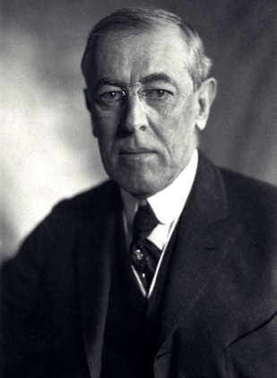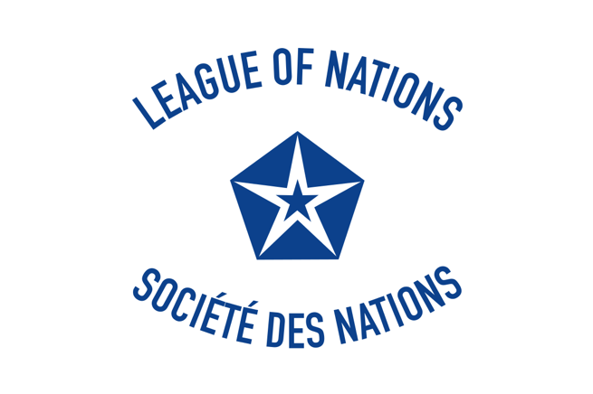

**What did these developments mean for Palestine-Israel?**

As we have already seen, before the First World War, Palestine-Israel was part of the Ottoman Empire. The Ottoman Empire had joined the war on the side of the Central powers including Germany in October 1914. So when the Central powers were defeated, there was no one to govern the Ottoman Empire. The League of Nations discussed this and came up with the idea of the Mandates system

**Mandates**

The idea that the territories of the former German and Ottoman empires, including Palestine-Israel, would be governed by the victorious powers of WWI until the League of Nations deemed that they were ready to govern themselves

The territories of the former German and Ottoman empires were divided into three groups:

**-Class A Mandates** - their independence was recognised but they would still be under British or French control) - *Iraq, Syria, Lebanon, Palestine-Israel*

**-Class B Mandates** (the Allies were directly responsible for the administration of these territories - *Tanganyika, parts of Togoland and the Cameroons, Ruanda-Urundi*

**-Class C Mandates** - to be administered as part of Allied territory - *South West Africa, New Guinea, Western Samoa, the islands north of the Equator in the western Pacific, Nauru*

The Mandates were meant to be **fairer than colonies** because the governing power was **responsible to the League of Nations**, and ultimately the aim was for the territory to achieve **self-determination** (govern itself). In reality, as we will see in the case of Palestine-Israel, the Mandates were quite colonial in nature

**The Middle East Mandates**

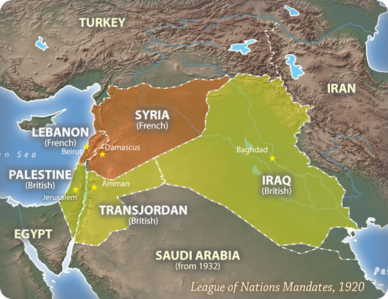

The former territories of the Ottoman Empire (Syria, Lebanon, Iraq and Palestine-Israel) were deemed **Class A Mandates**. This meant that their independence was recognised but they were still to be under British or French control

These parts of the former Ottoman Empire became:

-Mandatory Syria 🡪 allocated to France

-Mandatory Lebanon 🡪 allocated to France

-Mandatory Iraq 🡪 allocated to Great Britain

-Mandatory Palestine 🡪 allocated to Great Britain

- Mandatory Transjordan 🡪 became a British Mandate in 1922

Britain was assigned the Mandate for Palestine-Israel in **April 1920.** In **July 1920**, Britain established a **civil administration** in the country. The Mandate was then legally approved in **September 1923**.

Britain’s governance of Palestine lasted until **1948**

**Questions**

Which side of WWI did the Ottoman Empire join in October 1914?

What were the consequences of this for the Ottoman Empire?

Why was the League of Nations established?

Why was the Mandates system created?

What were the consequences of this for Palestine-Israel?

**Activity**

You are now going to be assigned Group A, B or C.

-Group A: Sykes-Picot Agreement

-Group B: Hussein-McMahon Correspondence

-Group C: Balfour Declaration

In your group, use your notes from Lesson 3 together with your homework to **prepare a short summary of your allocated promise**. Cover these questions:

-What was promised?

-How did Palestinians feel about this?

-How did Jews feel about this?

**Activity**

**What should Britain do?**

-Under the Hussein-McMahon Correspondence, Britain had promised to recognise Arab independence after the war

-Under the Balfour Declaration, Britain had promised to support a ‘national home’ for the Jews in Palestine-Israel

-Under the British Mandate for Palestine, Britain had promised the League of Nations to govern Palestine until it was ready to ‘stand alone’

**Insmall groups, imagine you are advising the British government in the 1920s. Can you think of a way for Britain to meet its promises to both Palestinians and Jews?**

Factors to consider:

-The long history of antisemitism in Europe. Should the Jews now have their own state?

-Jews were expelled from Palestine-Israel 2000 years ago. Do they have a right to return?

-Palestine-Israel is now home to Palestinians. Should they be able to keep their land?

Use these terms in your discussions:

-*Palestinian nationalism*: the movement to establish a Palestinian state in Palestine-Israel

-*Zionism*: the Jewish national movement to establish a Jewish state in Palestine-Israel

In the end, **the text of the Balfour Declaration was incorporated into Britain’s Mandate for Palestine**

**Extension activity**

Explain the significance of the Ottoman Empire’s defeat in WWI for those living in Palestine-Israel

**Check your knowledge!**

Define Mandate Palestine

Explain why Britain governed Palestine-Israel between 1920 and 1948

Compare Britain’s promises to Palestinians and Jews at this time